 **University of the Western Cape**

**Department of Computer Science**

**Private Bag X17, Bellville, 7535**

**CSC211- Data Structures and Algorithms II**

**Assignment 3 (25 Marks) Student number:**

-----------------------------------------------------------------------------------------------------------------------------------------

1. Consider the min heap below. Perform 5 deletion operations and show the resulting heap after each deletion. **[5]**

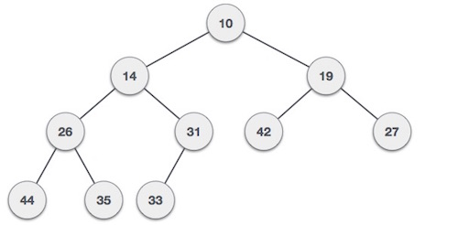

1. Sort the following list from **largest** **to** **smallest** using *heapsort*. Represent the heap by an array and show each step: S, O, R, T, I, N, G (A > B, B > C, C > D…. Y>Z). **[7**]
2. Consider the graph below, compute the **Positive-Weighted Shortest Path** from **A to G**. Please show your adjacency matrix**. [5]**

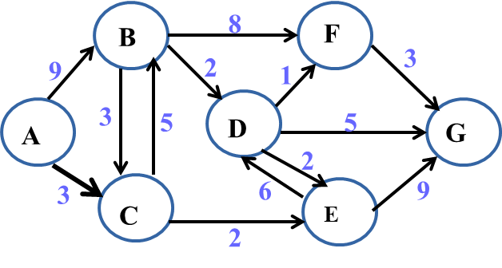

Figure 2

1. For the graph below, find the **unweighted shortest path** from V0 to V5, using Breadth-First Search. Please also show your Breadth First Tree. **[5]**

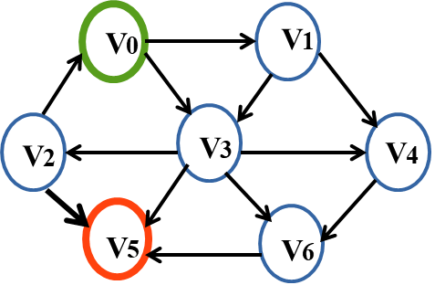

1. In **at most** **3 sentences**, differentiate between breadth-first traversal and depth-first traversal of graphs. [3]